SEO Metadata
- Focus Keyword: best digital marketing agency in Kolkata
- Meta Title: Best Digital Marketing Agency in Kolkata (2026 Guide) | Brewing Ideaz
- Meta Description: Looking for the best digital marketing agency in Kolkata? Learn what to evaluate — strategy, channels, reporting, pricing & red flags — before you hire.
- URL Slug: /best-digital-marketing-agency-in-kolkata

Secondary Keywords
- digital marketing agency in Kolkata
- best digital marketing company in Kolkata
- digital marketing services in Kolkata
- online marketing agency Kolkata
- SEO agency in Kolkata
- performance marketing agency Kolkata
- social media marketing agency Kolkata
- digital marketing company Kolkata
- digital marketing experts in Kolkata
- Brewing Ideaz Kolkata

Best Digital Marketing Agency in Kolkata: A Practical Guide to Choosing the Right Partner
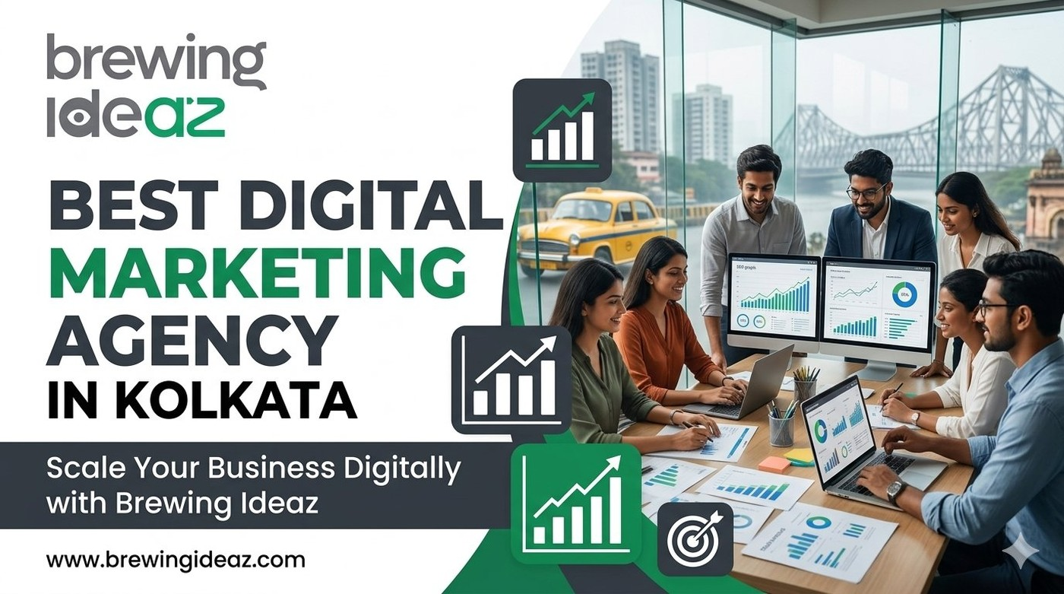
Kolkata’s business landscape is evolving quickly — traditional companies are digitising and new startups are competing for attention. Many agencies position themselves as the “best digital marketing agency in Kolkata,” yet results differ dramatically.
This guide helps you evaluate agencies with a clear set of criteria so you can choose a partner that delivers measurable growth.

What “Best” Means in Digital Marketing
A capable digital marketing agency goes beyond running campaigns. It should understand your business objectives, map the customer journey, and build an integrated approach across SEO, paid media, content, social media, email, and conversion rate optimisation.
The strongest agencies focus on pipeline and revenue outcomes rather than vanity metrics alone.
Fit is critical. An agency that excels at local consumer campaigns may not be the right match for a B2B or SaaS company, and vice versa.

Key Factors to Evaluate Before Hiring a Digital Marketing Agency

1. Strategic Foundation
A reliable agency should invest time in discovery, audience research, and goal alignment before recommending tactics.

2. Relevant Channel Expertise
Request case studies that match the channels and industries important to you — SEO, paid media, content marketing, social media, email marketing, and conversion rate optimisation.

3. Clear Reporting
You should receive transparent dashboards and regular reviews tied to business results.

4. Team Quality
Understand who will handle strategy and day-to-day execution, and their experience and responsibilities.

5. Pricing Transparency
Know what is included in the retainer or project fee and how additional work is charged.

6. Communication and Culture Fit
Confirm that the agency’s preferred working style aligns with yours — channels, meeting frequency, and reporting schedules.

Why a Kolkata-Based Agency Can Be Advantageous
Local agencies understand the city’s market nuances, media consumption patterns, and business culture. Collaboration can be smoother with overlapping working hours.

Questions to Ask Before You Hire
- How do you approach discovery and strategy development?
- Can you share recent case studies relevant to my industry or goals?
- What KPIs do you prioritise, and how do you report them?
- Who will be the core team working on my account?
- What does the first 90 days typically look like?
- How frequently will you share performance reports?
- What deliverables are included in the proposed package?
- How do you respond when a campaign underperforms?
- Will I have access to my advertising accounts and analytics data?
- How do you adapt your strategy when business goals change?

Red Flags to Watch For
Be cautious of agencies that guarantee instant number-one rankings, promise unrealistic returns in a short time, refuse to share references, or cannot explain their process and pricing clearly. Other warning signs: high-pressure sales tactics, vague contracts or hidden charges, reports that focus only on impressions or followers, and unwillingness to provide access to your own accounts and data.

How to Choose the Right Digital Marketing Agency for Your Business
- Define Your Marketing Goals — traffic, leads, brand awareness, sales, or retention.
- Identify the Services You Need — SEO, paid, social, content, email, or a combination.
- Review Relevant Experience — case studies, references, and similar businesses.
- Compare Proposals — strategy, deliverables, timelines, reporting, pricing.
- Agree on KPIs and Communication — measurable goals and review cadence.

Final Thoughts
The best digital marketing agency in Kolkata for your business is the one that understands your goals, brings the right expertise, reports honestly, and works as a true partner.

Ready to Discuss Your Growth Priorities?
Brewing Ideaz has a branch office in Kolkata, at Bangur Avenue, and a corporate office in Bengaluru.
Call or WhatsApp: +91 62915 47048 Email: info@brewingideaz.com

30 Frequently Asked Questions About Digital Marketing Agency in Kolkata
- What is a digital marketing agency? A digital marketing agency helps businesses promote their products or services through online channels such as search engines, social media, paid advertising, email, and content marketing.
- How do I choose the best digital marketing agency in Kolkata? Evaluate the agency’s strategy, relevant experience, service offerings, reporting process, pricing, communication, and ability to understand your business goals.
- What services does a digital marketing agency provide? Common services include SEO, Google Ads, social media marketing, content marketing, email marketing, performance marketing, and conversion rate optimisation.
- How much does a digital marketing agency in Kolkata charge? Pricing depends on the services required, campaign complexity, business goals, and agency experience.
- Why should I hire a digital marketing agency? An agency can provide specialised expertise, help execute marketing campaigns, track performance, and support your business’s online growth.
- Is a digital marketing agency suitable for startups? Yes. Startups may use agencies to build brand awareness, reach target audiences, generate leads, and develop strategies within budget.
- What is the difference between SEO and digital marketing? SEO focuses on improving a website’s visibility in organic search results. Digital marketing is a broader field that includes SEO, paid advertising, social media, email, and more.
- How long does digital marketing take to show results? The timeline depends on the channel, competition, budget, and strategy.
- What is performance marketing? A results-oriented approach measured using specific actions or outcomes, such as clicks, leads, purchases, or conversions.
- What is included in a digital marketing strategy? Business objectives, audience research, channel selection, content planning, budgets, campaign execution, and performance measurement.
- What is local digital marketing? Helping businesses reach customers in a specific geographic area through local SEO, business listings, location-based advertising, and relevant content.
- Can digital marketing help small businesses? Yes, it can improve online visibility, connect with potential customers, and generate enquiries.
- What is the role of SEO in digital marketing? SEO helps improve a website’s visibility in organic search results.
- What is social media marketing? Using platforms such as Instagram, Facebook, LinkedIn, and others to share content, engage audiences, and promote a business.
- What is content marketing? Creating and distributing useful, relevant content to attract and engage a target audience.
- How do I measure the success of a digital marketing campaign? Qualified leads, conversions, revenue, CAC, ROAS, and relevant engagement metrics.
- What is customer acquisition cost (CAC)? The amount a business spends to acquire a new customer, including relevant marketing and sales expenses.
- What is lifetime value (LTV)? An estimate of the total revenue or value a business expects from a customer over the relationship.
- What is conversion rate optimisation? Improving a website or landing page to increase the percentage of visitors who complete a desired action.
- What should I include in a digital marketing agency contract? Services, deliverables, fees, timelines, reporting, account access, responsibilities, data ownership, and cancellation terms.
- How often should a digital marketing agency provide reports? Depends on the campaign; many businesses use monthly reports alongside more frequent updates for active campaigns.
- What is Google Ads? An online advertising platform that allows businesses to display paid ads across eligible Google properties and partner placements.
- What is the difference between organic and paid marketing? Organic marketing attracts audiences without paying per placement; paid marketing uses budgets to reach audiences through paid placements.
- Can a digital marketing agency help with lead generation? Yes, using SEO, paid advertising, landing pages, content, and other channels.
- What is a digital marketing audit? An evaluation of a business’s online marketing activities, including website, SEO, advertising, content, and analytics.
- Should I choose a specialised agency or a full-service agency? Depends on your business needs, internal resources, and campaign requirements.
- What are common mistakes businesses make when hiring a digital marketing agency? Choosing solely based on price, failing to define goals, overlooking contract terms, ignoring reporting quality, and not checking relevant experience.
- Does a digital marketing agency guarantee results? No agency can reliably guarantee specific outcomes such as first-place rankings or a fixed ROI.
- What should I prepare before contacting a digital marketing agency? Business goals, target audience, current marketing performance, budget range, required services, and relevant campaign information.
- How can I contact Brewing Ideaz for digital marketing services in Kolkata? You can contact Brewing Ideaz by calling or WhatsApping +91 62915 47048 or emailing info@brewingideaz.com.

